Hotfix Manager in Pega

Hotfixes are .zip packages of files that address issues in the Pega Platform and participating Pega-supplied applications. Hotfix Manager includes both a user-interface tool and a command-line tool. You can perform the same actions from both tools. To use Hotfix Manager, you must have administrator rights.

Use Hotfix Manager to perform the following actions:

* Scan your system to identify necessary hotfixes and help you communicate with Pegasystems Inc. support
* Install hotfixes
* Roll back [uncommitted hotfixes](https://docs-previous.pega.com/sites/default/files/help_v73/definitions/u/uncommittedhotfix.htm)
* Manage hotfixes that include schema changes or require other special handling

Hotfix life cycle

The hotfix life cycle includes these states:

* **Not installed**- Hotfixes that are not yet installed on your system. The Pega Platform cannot use these hotfixes.
* **Installed but uncommitted**- Uncommitted hotfixes are installed in your system; the Pega Platform can use these hotfixes, however they can still be rolled back to remove them from the system.
* **Rolled back** - Rolled back hotfixes were installed, but have been removed from the system. The Pega Platform cannot use these hotfixes.
* **Committed**- Committed hotfixes are permanent on the system. You cannot roll back a committed hotfix.

Managing hotfix packages

Follow these steps to use Hotfix Manager to manage hotfixes to your system:

1. Obtain a [hotfix catalog](https://docs-previous.pega.com/sites/default/files/help_v73/definitions/h/hotfixcatalog.htm) on-line or from Pegasystems Global Customer Support.
2. Scan your system to compare the current inventory of rules, code, and hotfixes to the latest hotfix catalog. The scan identifies hotfixes that are:
   * Installed
   * Not installed
   * Incorrectly installed
   * Superseded by more recent hotfixes
3. If you need a hotfix, use My Support Portal to create a service request.
4. Install the hotfix.
5. Before you commit, test the uncommitted hotfix.
6. When you are sure the hotfix meets your needs, commit the hotfix. If the hotfix does not meet your needs, roll back the hotfix.

Hotfixes supported by Hotfix Manager

Hotfix Manager supports these types of hotfixes:

* Rule changes including data instances and non-versioned rules that do not go through rule resolution
* Code and engine changes
* Some schema changes:
  + Adding tables
  + Adding views
  + Adding or modifying columns
  + Adding or modifying indexes

Hotfix Manager does not support the following types of hotfixes. If you attempt to use Hotfix Manager for these hotfixes, you will see an error and the hotfix will not install:

* Changes to EAR or WAR files
* Changes to scripts in the distribution: install, upgrade or command line scripts
* Other schema changes not listed above

So when tried on the pega instance

Click on Configure > System > Release > Hotfix Manager

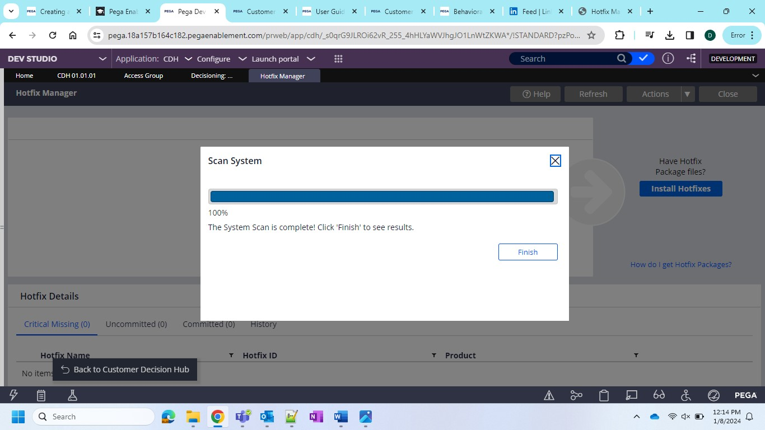

Then click on Scan the system will scan and give you result

So as per my system result the following are the scans

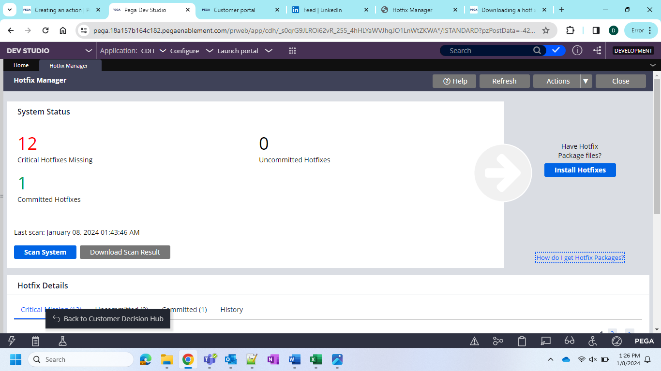

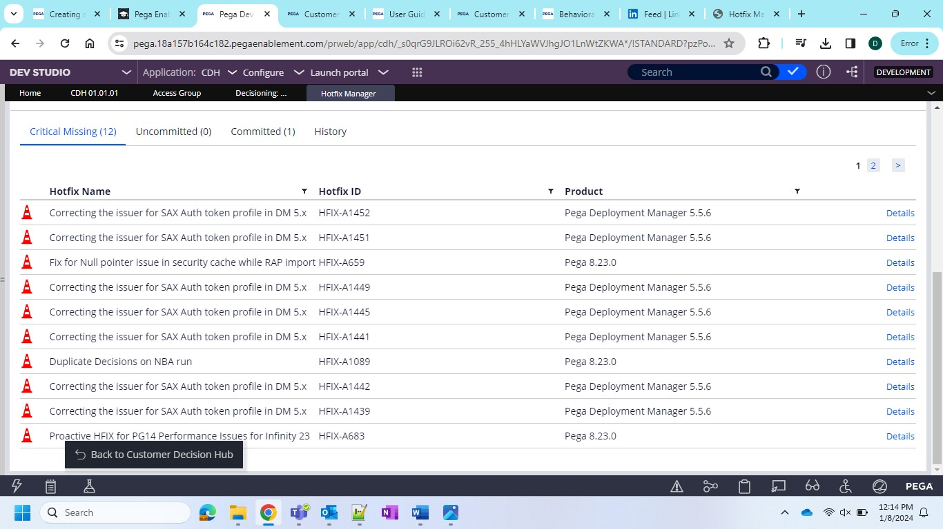

So as per result some are verified some needs to be installed so need to check and get in touch with pega and solve these hotfixes.